**BOXER-6646-ADP**

**Fanless Embedded controller with Intel Alder Lake-P (U28) Platform**

**Engineering Specification**

**Rev. 0.5**

**2022/10/05**

|  |  |  |
| --- | --- | --- |
| **PM** | **PM** | **Raven** |
| **RD** | **H/W** | **Michael** |
| **S/W** | **Ian** |
| **ME** | **Eric** |
| **QE** | **Leol** |
| **TS** | **Chasel** |

**Revision History**

|  |  |  |  |
| --- | --- | --- | --- |
| **Revision History** | | | |
| Rev | Brief Description of Changes | Date of Issue | Author(s) |
| 0.1 | Preliminary release | 2022/04/19 | Raven Hsu |
| 0.2 | Remove IP40 compliance | 2022/05/10 | Raven Hsu |
| 0.2 | Update PM/RD information | 2022/06/22 | Peggy Kao |
| 0.3 | Update Ubuntu version to 20.04.4 | 2022/07/27 | Raven Hsu |
| 0.4 | Update Ubuntu version to 22.04.1 | 2022/08/31 | Raven Hsu |
| 0.5 | Update spec based on Ver. A1.0 motherboard   * Delete: Full size miniPCIe * Add: M.2 3052 B Key | 2022/10/05 | Raven Hsu |

**Features**

■ Intel 12th Gen Alder Lake-P U28 Processor  
■ Dual-Channel DDR5 SODIMM, Total max. 64GB  
■ SuperSpeed+ USB3.2  
■ Support Multi-LAN including 2.5GbE Ethernet  
■ Support High Speed NVMe storage (M.2 2280)  
■ Intel 2.5GbE (i226-LM) x2, GbE PHY x1 (i219-LM)  
■ Support vPRO, iAMT

■ Onboard TPM 2.0  
■ Wide Range 10-35V (with tolerance 9-36V) DC input  
■ Wide Range -20~60 °C Operating Temperature

# Specifications

* 1. **Main Specification**

|  |  |
| --- | --- |
| Engineering Specification | |
| Product Name | BOXER-6646-ADP-A1-1010 (i3-1220PE)  BOXER-6646-ADP-A2-1010 (i5-1250PE)  BOXER-6646-ADP-A3-1010 (i7-1270PE) |
| Construction | Rugged Aluminum Alloy & Cold Roll Steel |
| CPU | Intel® 10nm Alder Lake-P (U28) Processor  Intel® Core™ i7-1270PE Intel® Core™ i5-1250PE Intel® Core™ i3-1220PE |
| Chipset | Intel® SoC |
| System Memory | DDR5 SODIMM x2, max. up to 64GB |
| Display | HDMI Type A x2  DisplayPort x2 |
| Storage | Swappable 2.5” SATA-III Drive Bay x1  M.2 2280 M Key NVMe Slot x1 (PCIEx4) |
| Ethernet | GbE LAN x2 with LED Indicator   * + - Intel i219-LM x1 (PHY)     - Intel i226-LM x2 |
| I/O | HDMI x 2 + DP x 2  RJ45 x 3 for 1G/2.5GbE LAN  USB Type A x 3 for USB 3.2  USB Type A x 3 for USB 2.0  DB-9 x 4 for RS-232/422/485 (Autoflow)  DB-15 x1 for 8-bit DIO  Audio Line out, (default ALC-888S, co-lay with ALC-897)  DC 10~35V 3-pin Terminal Block Connector  Power button with power LED x 1 |
| Antenna opening x 4 |
| Remote Power On/Off x1 |
| Expansion Function | M.2 E-Key 2230 x1 (For WiFi/Bluetooth Module)  M.2 B-Key 3052 x1 (For 5G/LTE module)  M.2 M-Key 2280 x1 (For NVMe Storage)  TPM2.0 (Onboard)  Wafer x2 for USB 2.0  Wafer x2 for RS232/422/485  SATA-III x1 (6 Gb/s, for 2.5” SATA drive bay) |
| Mounting | Wall mount kit (default) |
| Power Supply | DC 10V~35V (with tolerance 9-36V) 3-pin terminal block ATX mode  Support Power Protection: OCP/OVP/UVP/SCP/RVP |
| Dimensions | 220 x 154 x 61.6mm |
| Net weight | TBD |
| Gross weight | TBD |

* 1. **Environmental Specifications**

|  |  |
| --- | --- |
| Operating temperature | -4°F ~ 140°F (-20°C ~ 60°C), according to IEC68-2 with 0.5 m/s AirFlow  (w/ Industrial wide Temp. SSD/RAM) |
| Storage temperature | -40°F ~ 176°F (-40°C ~ 80°C) |
| Storage humidity | 5 ~ 95% @ 40C, non-condensing |
| Vibration | Random, 3 Grms, 5~500Hz (with SSD) |
| Shock | With SSD: 50 G, IEC 60068-2-27, half sine, 11 ms duration |
| Drop | 76 cm (1 Corner, 3 Edge, 6 Surface) |
| EMC | CE / FCC class A |
| Safety | TBD |

* 1. **OS Support**

|  |  |  |
| --- | --- | --- |
| **Operation System** | **Support** | **Notes** |
| Windows 10 PRO | *V* |  |
| Windows 10 IoT Enterprise LTSC 2021 H2 | *V* |  |
| Windows 11 PRO | *V* | Windows 11 IoT is Not released by Microsoft |
| Linux Ubuntu 22.04.1 (Kernel 5.15 or above) | *V* |  |

1. **Ordering Information**

|  |  |
| --- | --- |
| **Part Number** | **Description** |
| BOXER-6646-ADP-A1-1010 | EC.i3-1220PE.2HDMI,2DP. M.2 NVMe/2230/3052,3LAN.4USB3+2USB2,4COM.9-36V |
| BOXER-6646-ADP-A2-1010 | EC.i5-1250PE.2HDMI,2DP. M.2 NVMe/2230/3052,3LAN.4USB3+2USB2,4COM.9-36V |
| BOXER-6646-ADP-A3-1010 | EC.i7-1270PE.2HDMI,2DP. M.2 NVMe/2230/3052,3LAN.4USB3+2USB2,4COM.9-36V |

1. **System Design**
   1. **BOXER-6646-ADP Board Diagram**

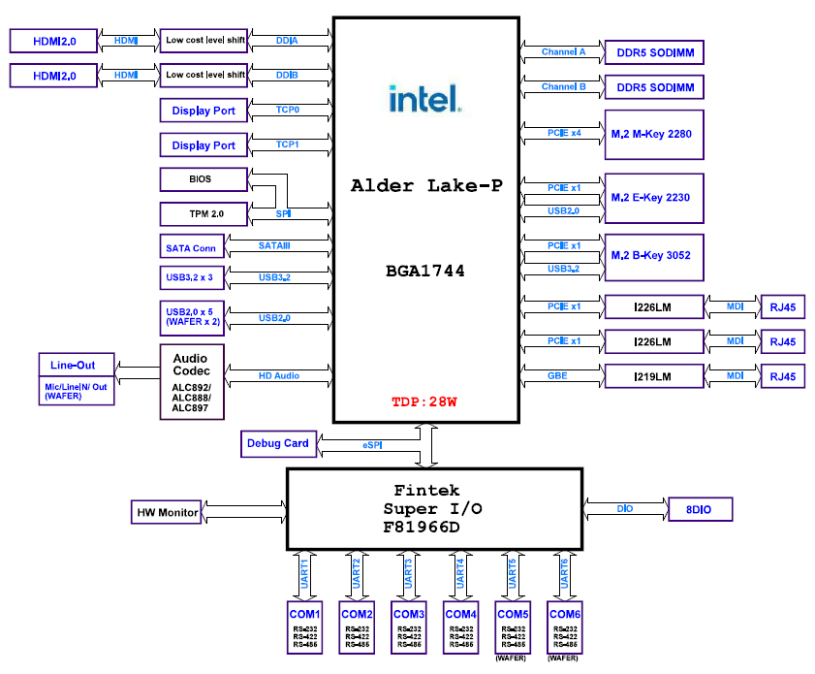

1. **System Dimension**

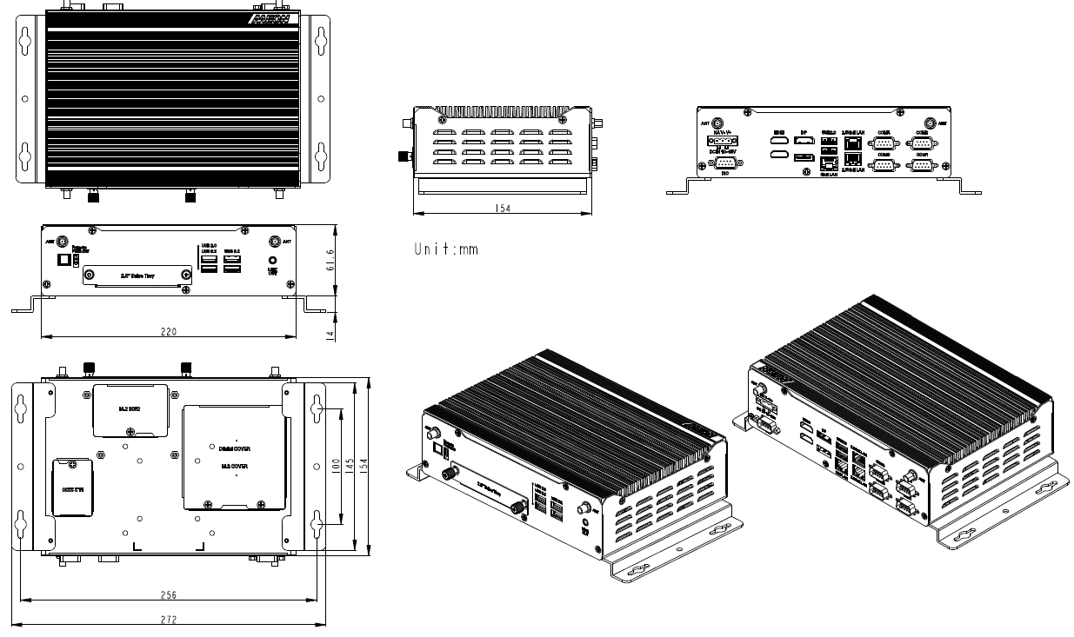

1. **Packing Information**
   * + BOXER-6646-ADP x1
     + Wallmount Kit x1
     + Screw Pack x1
     + 3pin Terminal Block for DC in x1
     + Remote Power On/Off connector x1
2. **Optional Accessory**
   * + Power Adapter
     + Power Cord
     + DRAM
     + HDD/SSD/NVMe